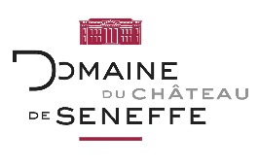
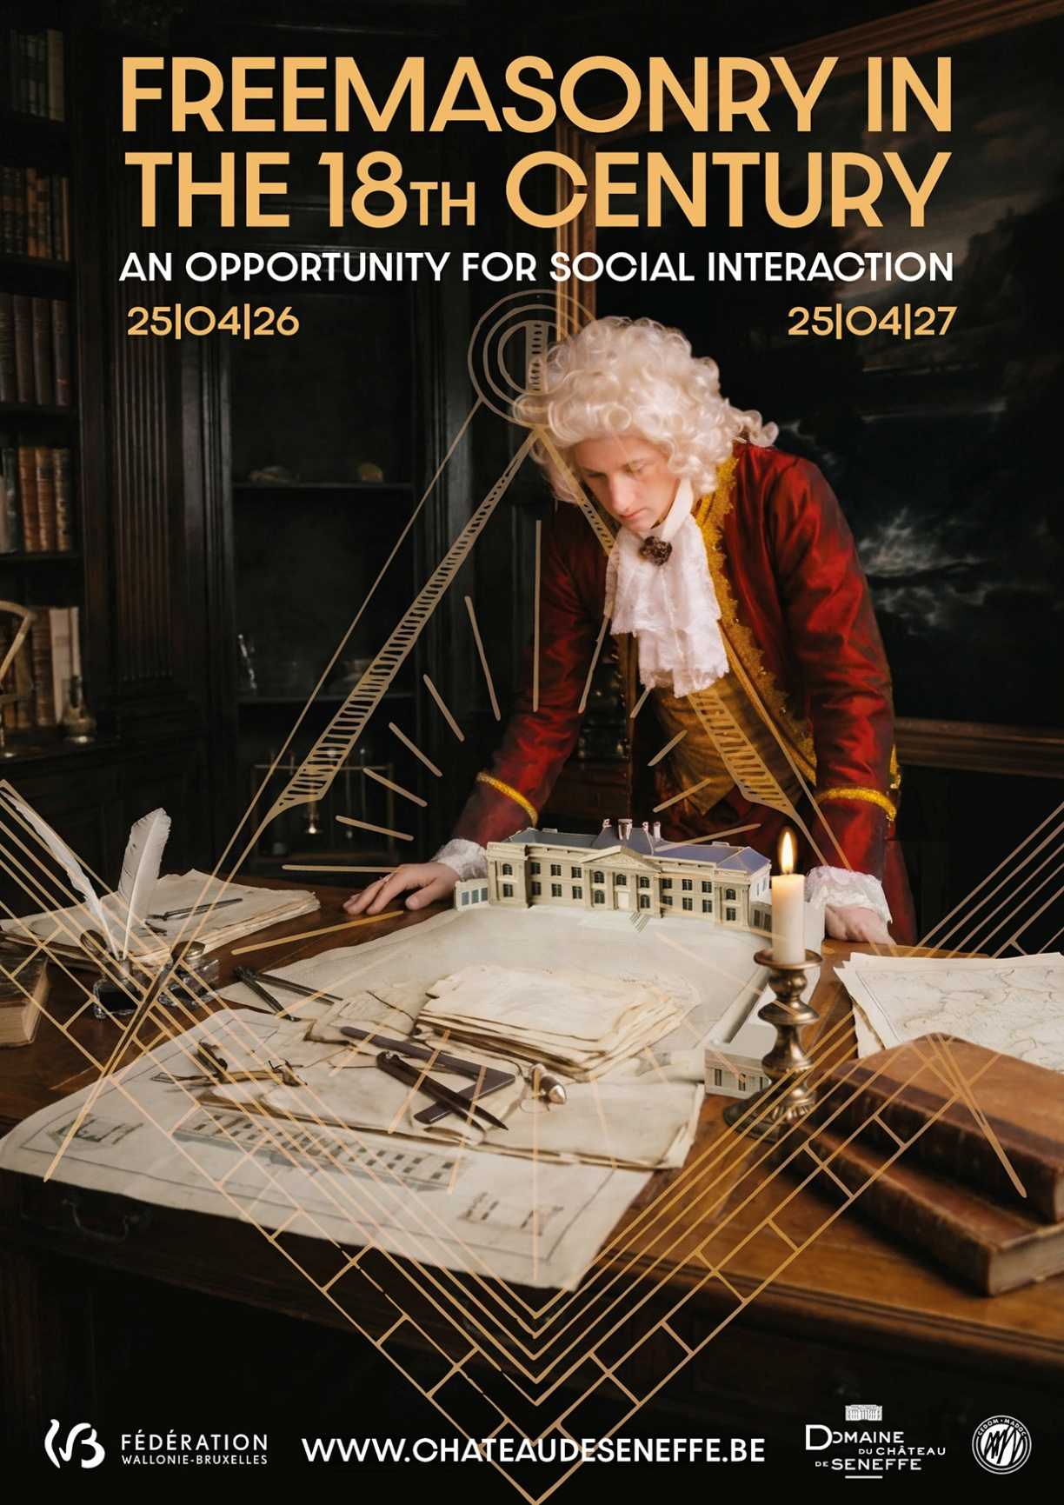
© Domaine de Seneffe asbl-Intervention graphique: European pictures - Photo: L. Artamonow

From 25 April 2026 to 25 April 2027, Château de Seneffe throws light on a key 18th-century phenomenon with the exhibition Freemasonry in the 18th century: an opportunity for social interaction. At the very heart of the Enlightenment, lodges became unprecedented spaces for social encounter, debate and the circulation of ideas, where nobles, scholars, artists, soldiers and travellers mingled. The exhibition leaves behind the myths and tall stories to explore a form of social activity based on equality, the willingness to listen and individual progress. In the superb setting of the Seneffe estate, art objects, archives, scientific instruments, books and Masonic artefacts tell of the intellectual ferment of a Europe in the midst of change. A fascinating insight into a laboratory of ideas that shaped modernity.
A free exhibition – in the spirit of social exchange that was so valued by the Enlightenment – presenting 18th-century Freemasonry from a fresh perspective, true to its values and rituals.
Marjolaine Hanssens
Exhibition curator.

Open every day from 10 am to 6 pm (last admissions at 5.30 pm), apart from working Mondays and 24, 25 and 31/12 and 01/01 ... Individual visits, guided tours, evening events on request ... Dining by reservation

Château de Seneffe
+32 (0)64 23 93 55
patriciadewames@chateaudeseneffe.be
WWW.CHATEAUDESENEFFE.BE

Blink PR
+32 (0)2 350 43 56
press@blinkpr.be
BLINKPR.BE

VISIT THE EXHIBITION

Copyright © 2026, BLINK PR All rights reserved.
Ariane Abramowicz & Bavo Verstraeten
02/350 43 56
Our mailing address is:
press@blinkpr.be

